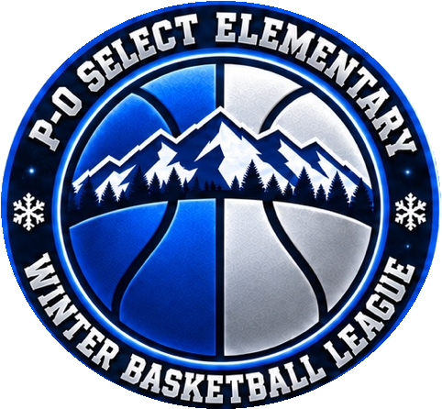

P O Select League
Public Relations Internet and Photo Release Form
The P-O Select League website may include articles and photographs featuring league games, activities, awards, and events throughout the season and year. These updates help keep our families informed and our community involved.
Every effort will be made to protect the individual identity of league members. Telephone numbers and addresses will not be posted on the website for public view. The league does not share or sell your contact information to others.
Student-athletes, coaches, and staff may also be featured in local newspapers. We are requesting permission to use photographs of your student-athlete on the league website, league social media accounts, and in publications about the P-O Select League, including local newspaper coverage.
Permission Selection
Please select one option below.
☐ I DO grant permission to the P-O Select League to use photographs of my student-athlete for the purposes described above.
☐ I DO NOT grant permission to the P-O Select League to use photographs of my student-athlete for the purposes described above.
________________________________ _______________________________
Parent/Guardian Signature Date
________________________________ _______________________________
Parent/Guardian First Name Parent/Guardian Last Name
________________________________ _______________________________
Student-Athlete First Name Student-Athlete Last Name

